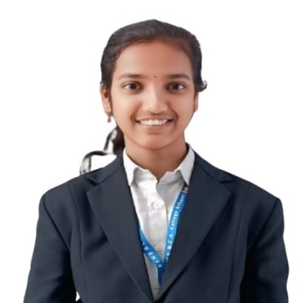
RESUME
Name: Samiksha Beerappa Waghamode
Email-id: samikshawaghamode2005@gmail.com
Phone no: 9168207532
Career objective:
To obtain an opportunity where I can apply my knowledge,skills,and dedication to contribute to the growth of the organization while gaining practical experience and building my career.
Technica Skills:
- Programming languages : c, java
- Web Technologies : Html, css
- Soft Skills : Teamwork, problem solving, Time Mangement
- Tools : Microsoft Words, VS Code, Basic MS Excel
- Databases : Basic MySql, Sql
- Languages : Englisg, Kannada, Marathi
Education:
- BCA (Bachelor of Computer Applications)
Rani Channamma University (RCU), Belagavi 86.42%(till 4th Sem )
- PUC
Karnataka Secondary Education Examination Board (KSEEB) 78.33%
- SSLC
Karnataka Secondary Education Examination Board (KSEEB) 86.89%
Certifications:
- Frontend Web Development
- Backend Web Development
Projects:
Bank Finance Mangement System Project link : https://github.com/samikshawagha/Financial • Developed a Java-based Bank Finance Management System to calculate loan interest and total payable amount. Used Scanner class and core Java concepts to handle user input and display financial summaries.

